EXPERIMENT 1A
Aim:

To analyze the trend in the number of data science job postings over the last decade using python.

Algorithm:

# Create the data for years and job postings using python lists.

# Use matplotlib.pyplot to plot a line.

# Set the x-axis as years and y-axis as no. of job postings.

# Add label for x-axis, y-axis and title for the graph.

# Use plt.plot() to draw the line and plt.show() to display the graph.

# Observe the trend of job postings over the years.

Code:

import matplotlib.pyplot as plt decade=[2014, 2015, 2016, 2017, 2018, 2019, 2020, 2021, 2022, 2023, 2024] Jobs=[1200, 1600, 2200, 3400, 5000, 7500, 8900, 9600, 10200, 11000, 11800] plt.figure(figsize=(6,4)) plt.plot(decade, Jobs, color='black', marker='o', linestyle='--', label='Line P plt.title("LINE PLOT") plt.xlabel("decade") plt.ylabel("jobs") plt.grid(True) plt.show()
l
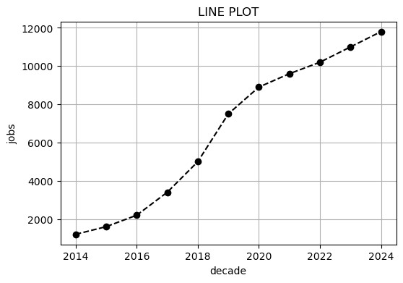

Result:
Thus the python program to analyze the trend of datas over last decade was written and executed successfully and the output got verified.

EXPERIMENT 1B
Aim:
To visualize the distribution of different data science job role using charts.
Procedure:
1.Import matplotlib.pyplot for plotting
2.Create two lists: one for job poles and one for their corresponding vacancy counts
3.Use plt.bar() to draw a bar chart with roles on the x-axis and vacancies on the y-axis.
4.Add a title and axis labels using plt.title(),plt.xlabel() and plt.ylabel()
5.Use plt.show() to display the bar chart
6.Observe which roles have higher or lower job demand.

Code:
In [2]:
import matplotlib.pyplot as plt
C=['Data Scientist', 'Data Analyst', 'Data Engineer', 'ML Engineer', 'Business y=[1500, 900, 860,740,600] plt.figure(figsize=(8,4)) plt.bar(C,y,color='blue') plt.title("bar chart") plt.xlabel("data roles") plt.ylabel("job vacancy") plt.show()
A
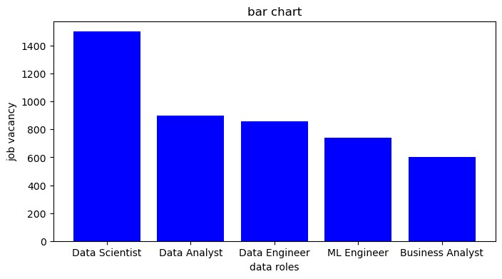

Result:
Thus the python program to analyze and visualize the distribution of various data science roles was written and executed successfully and the output got verified.

EXPERIMENT 1C
Aim:
To understand and demonstrate the differences between structured, unstructured, and semi-structured data using Python.
To create and display examples of each type of data.
Procedure:
- Create a structured dataset using a dictionary and convert it to a DataFrame.
- Print the structured data to visualize rows and columns.
- Define unstructured data as a list of text and print it.
- Create semi-structured data using a dictionary and print its key-value pairs.
- Execute the program and verify the output for all three data types.

import pandas as pd
Structured_data={
'Name': ['Kaviya', 'kalai', 'deepi'],
'ID': [101,103,105],
'Marks': [93,87,85]
}
df=pd.DataFrame(Structured_data) print("STRUCTURED_DATA:") print(df)
In [3]:

STRUCTURED_DATA:
Name ID Marks 0 Kaviya 101 93
- kalai 103 87
- deepi 105 85

unstructured_data=[
"Unstructured data is information that does not have a predefined format or
]
print("UNSTRUCTURED_DATA:") print(unstructured_data)
In [5]: a

UNSTRUCTURED_DATA:
['Unstructured data is information that does not have a predefined format or a sp ecific organization, unlike data in a traditional row-column database. It include s a wide variety of files like text documents, images, audio files, videos, and s ocial media posts. Because it lacks a consistent schema, this data is more challe nging to store, process, and analyze with traditional tools and often requires ad vanced techniques like natural language processing (NLP) and machine learning (M L) to extract meaningful insights.']

semi_structured_data={
"Name": "Kaviya",
"Dept": "CSE",
"Subjects": "FDS, DBMS, JAVA"
}
print("SEMI_STRUCTURED_DATA:") for key, value in semi_structured_data.items():
print(f"{key}:{value}")
In [6]:

SEMI_STRUCTURED_DATA:
Name:Kaviya
Dept:CSE
Subjects:FDS, DBMS, JAVA

Result:
Thus the python program to differentiate structured, unstructured and semi-structured data was written and ex
ecuted successfully and the output got verified.

